**Page 6 –**

[**https://ensurekar.com/msme-registration**](https://ensurekar.com/msme-registration)

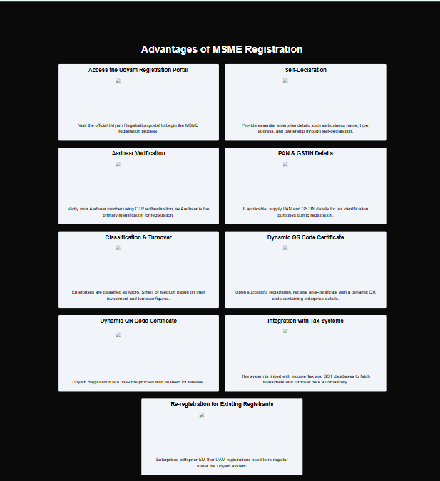

1. 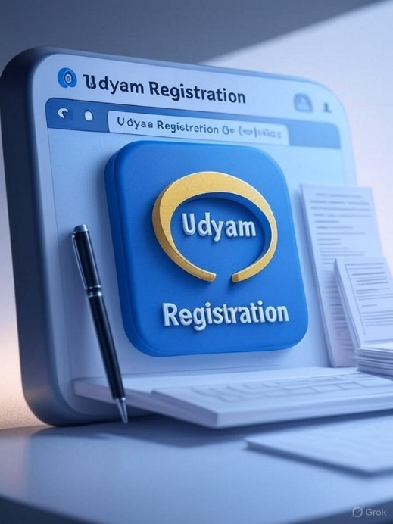**Access the Udyam Registration Portal**



**2. Self-Declaration**

**3 Aadhaar Verification**

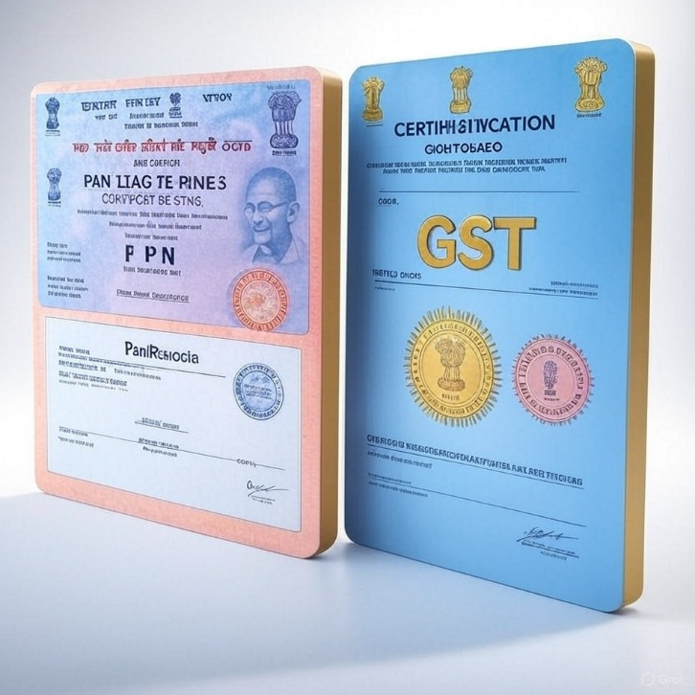

**4. PAN & GSTIN Details**

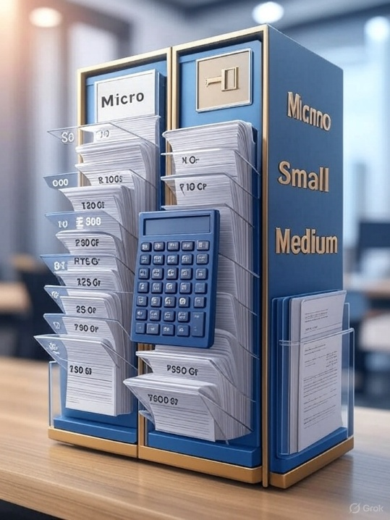

**5. Classification & Turnover**



**6. Dynamic QR Code Certificate**

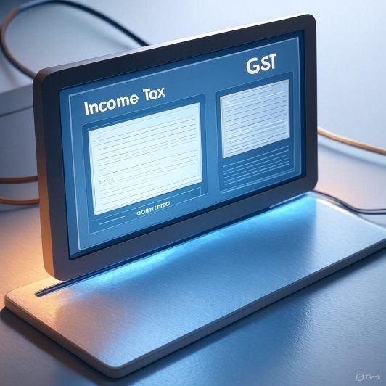**7. Integration with Tax Systems**

**8. Re-registration for Existing Registrants**

